1. **Initial Project**

1. **Resized and compressed images and added the responsive picture element**

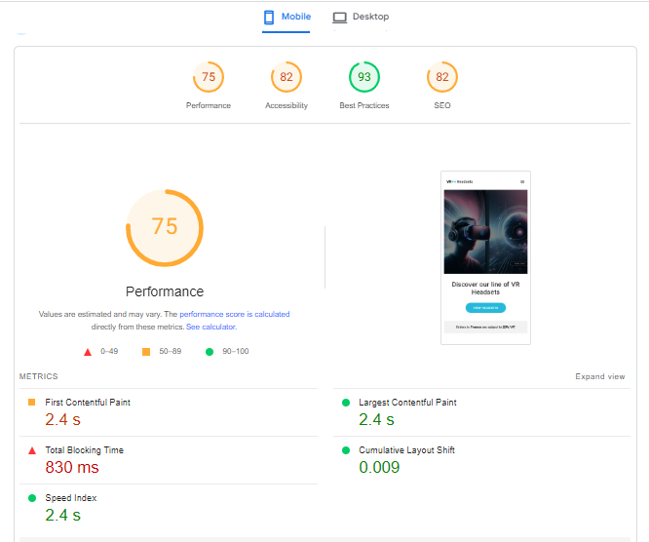

1. **Set height and width attributes for images**

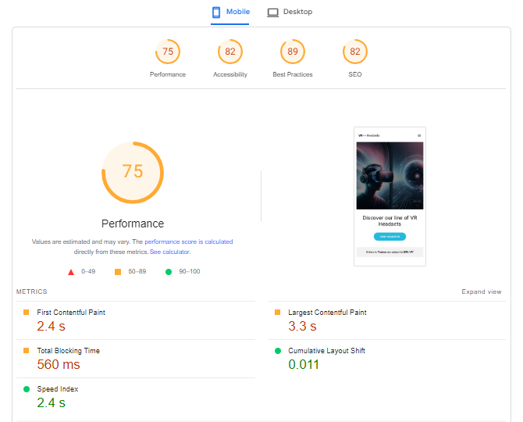

1. **Lazy loading / Reducing initial javascript execution time**



